The side of the Earth that faces the Sun has day.
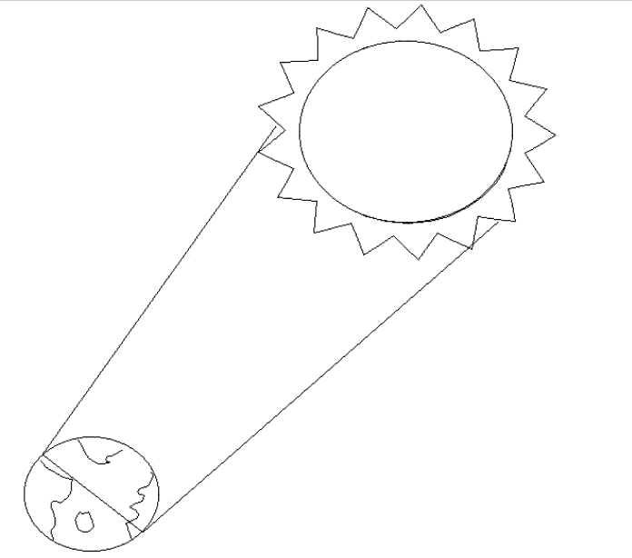
The side of the Earth that is away from the Sun has night.

Colour the Sun and the Earth.
Colour the side of the Earth with day yellow.
Colour the side of the Earth with night dark grey.

