The Moon is the Earth’s satellite.
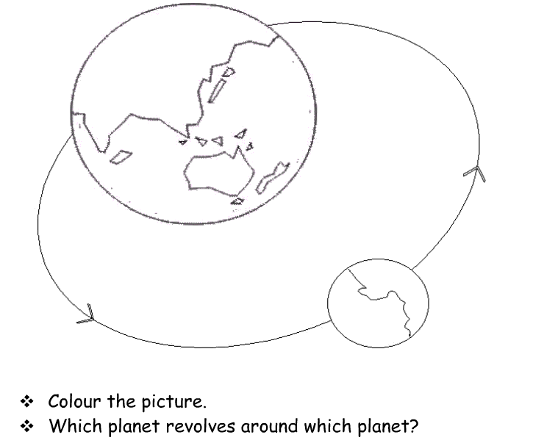
It takes 28 days to go around the Earth.

